SOIL ANALYSIS AND CROP CULTIVATION

AND PREDICTION

Abstract -:

Soil analysis is an important process to determine the available plant nutrients in the soil. Plants absorb the major nutrients through soil. In addition to soil, there are various major factors like rainfall, precipitation, fertilizer etc. that affect plant growth. Our aim is to create a prediction engine for most suitable crop for a particular soil. As an initial step, we have focused on predicting the accurate crop yield to the user by analyzing the soil fertility and rainfall in the region entered by the user as an input.

Keywords : Soil analysis, Crop prediction, Algorithms

Introduction -:

* Agriculture is the pillar of the Indian economy and more than 50% of India’s population are dependent on agriculture for their survival.
* There are various machine techniques used in agriculture for yield prediction, smart irrigation system, crop disease prediction, crop selection, weather forecasting, deciding the minimum support price, etc.
* Machine learning techniques will enhance the productivity of the fields along with a reduction in the input efforts of the farmers.

Literature Review -:

1. Detection of soil type using threshold k-mean cluster and ANN algorithm. The author of this paper is Trimi Neha Tete. ,Sushma Kamlu. And it was published in the year 2017.

* Concept -:To discuss various techniques of segmentation for identification of different soil type.

* Advantages-:

1. Low amount of effort are needed
2. Low cost

* Disadvantages-:

1. ANN is timetaking.
2. Result transperancy is low.
3. It is slower in execution speed.

1. Progress towards machine learning methodologies for laser-induced breakdown spectroscopy with an emphasis on soil analysis.The author of this paper are Yinchao Huang and Abdul Bais.This paper was published in the year 2022.

* Concept-: Optical immision spectroscopy of laser-produced plasmas, commonly known as Laser-Induced Breakdown Spectroscopy (LIBS), is an emerging analytical tool for rapid soil analysis.
* Advantages-:

1. It enables multivariate data analysis and offers advantages in data processing, signal analysis, and pattern recognition.
2. Simple and rapid analysis.

* Disadvantages-:

1. Detection limits are generally not as good as established solution techniques.
2. Poor precision – typically 5-10%, depending on the sample homogeneity, sample matrix, and excitation properties of the laser.

Proposed Analysis-:

For crop analysis, we need to monitor various environmental parameters such as temperature, humidity and moisture.

Depending upon this respective parameters overall analysis of the soil is being carried out in this project. Crop selection method has been developed for season wise crop prediction. Therefore, based on kharif(crops which are sown at the beginning of the rainy season e.g between april and may), rabi crops(crops that are sown at the end of monsoon or beginning of winter season, e.g between September and october). These crops are known as monsoon crops. And zaid crops(short season between kharif and rabi season in the months of march to July), the seasonal crops will be predicted. For prediction, we have compared and analysed different algorithms.

* Support vector machine algorithm :
* SVM is one of the most supervised learning algorithms, which is used for classification as well as regression problems.
* Random forest algorithm :
* Random forest is a classifier that contains a number of decision trees on various subsets of the given dataset sand takes less training time as compared to other algorithms.
* It predicts output with high accuracy, even for the lage dataset it runs efficiently.
* Decision tree classification algorithm :
* It is a tree structured classifier, where internal nodes represent the features of a dataset, branches represent the decision rules and each leaf node represent the outcome.
* In a decision tree, there are two nodes, decision node and leaf node.
* Decision nodes are used to make any decision and have multiple branches, whereas leaf nodes are the output of those decisions and do not contain any further branches.
* K-nearest neighbour algorithm –:
* This algorithm is used to solve the classification model problems, K-NN basically creates an imaginary boundary to classify the data. When new data points come in, algorithm will try to predict that to the nearest of boundary line.
* Therefore, larger k value means smoother curves of separation resulting in less complex models. Whereas, smaller k value tends to overfit the data resulting in complex models.

Result -:

Soil test results includes the amount of nitogen(N), phosphorus(P), potassium(K), calcium(Ca), magnesium(Mg),copper(Cu), Iron(Fe), etc. in the soil. Other soil characteristics that may be included in soil test results are organic matter, soil pH, soluble salts etc. Factors that affect the soil test results are temperature, humidity, pH, rainfall etc.

1. Phosphorus :

It is needed by the plant to store energy created from photosynthesis and carbohydrate metabolism to be used for plant growth and reproductive processes. Phosphorus is not naturally abundant in the soil as other macronutrients and is relatively immobile. Th amount of available P in the soil solution is related to soil pH.

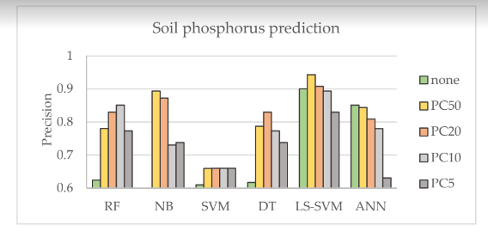

1. Potassium :

Potassium helps plants activate enzymes, draw water into roots, produce phosphate molecules and co2, translocate sugars, and uptake and assimilate N. Most soils contain K in large quantities, although it is not always available.

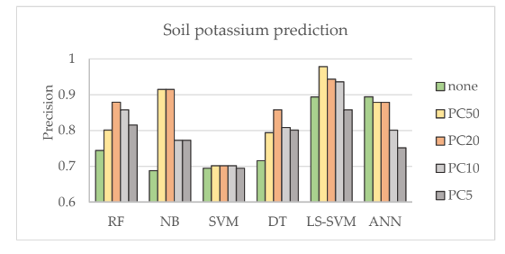

1. Magnesium :

Magnesium is needed for photosynthesis and in many other physiological and biochemical functions within the plant. Both Mg and Ca ions can be easily exchanged or removed from negative soil colloids. Concentrations og Mg in th soil are commonly 5-50 ppm in temperature soils but can be much higher.

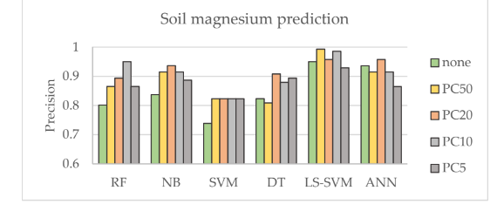

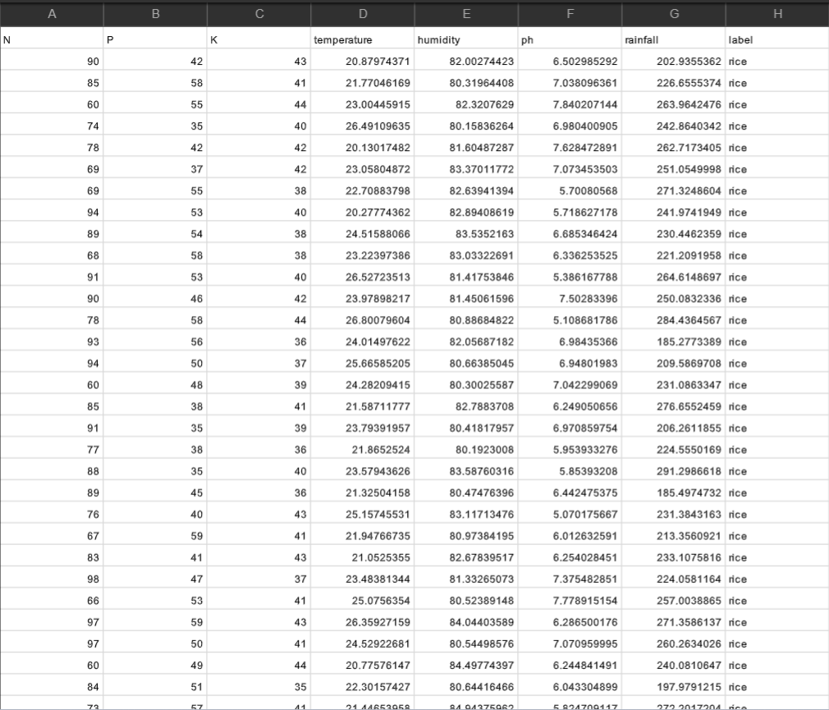

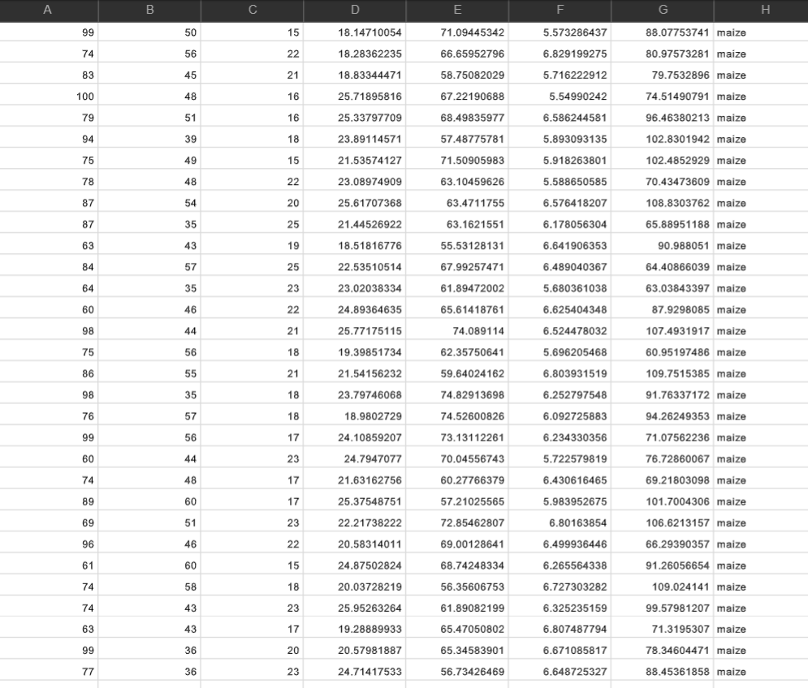

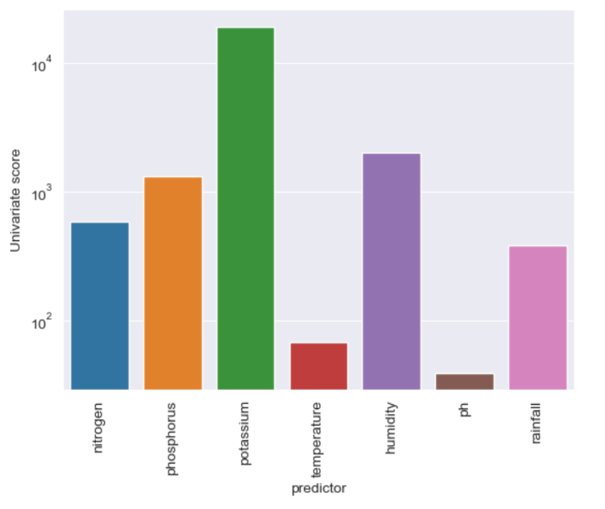

Conclusion -:

In this project, analysis of soil based on the temperature and soil moisture has been proposed using machine learning and classification algorithms. The project has high efficiency and accuracy in fetching the data of the proposed soil. The project will assist the farmers in increasing the agriculture yield and take efficient care of food production as the stick will provide helping hand to farmers for getting 99% accurate results of environmental temperature and soil moisture.